Commission size: (L __x W__) ___Bust ___ Waist Up ___ Full Body | ___Color ___ B&W
PHYSICAL DESCRIPTION Tattoos, scars, piercings, etc.
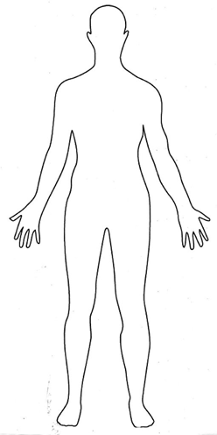
FRONT BACK
Age: Fancast:
Height:
Notes on gender/ presentation:
Hair (style, type, color):
Eyes (color, glasses):
Skin Tone:
Body build:
Clothing Preferences:

Other:

PERSONALITY:
Personality Type:
Common Mood:

RELEVANT HISTORY/ WORLD AESTHETICS :

NOTABLE SYMBOLIC IMAGERY;
Visual symbols or objects that are significant to your character:
(stars, snakes, shadows, antlers, a particular symbol, star wars, crayons, etc)

